Faith That Grows
As Christians, we are often told that we need to have faith. But what is faith? From a world view, faith can be defined as the opposite of reason or a belief in something without any evidence. Webster defines faith as “A firm belief in something for which there is no proof”
The Bible defines faith, in Hebrews 11:1, as “confidence in what we hope for and assurance about what we do not see.”. Here we find words like “assurance” and “confidence” which suggest it is more than just blind hope and wishful thinking. This verse suggest that faith is putting your trust in something you have good reason to believe in. The original words used in the Bible for hope meant waiting in eager expectation. The Bible has given us plenty of good reasons to believe in a loving creator and just looking at the amazing universe we live in and realize it would take pure blind faith to believe that it all happened by chance.
We can compare faith to wind or gravity. We cannot see it but we know it is there because we can see the effects it has on things around us.
Faith is more than just believing in God and Jesus, it is trusting God in every step you take through life.
Now Faith usually does not happen overnight. You don’t wake up one morning and find you have a perfect and unfaltering faith in something. Faith takes time and sometimes trials to build.
When Jesus was here on earth he often told parables, which was an earthly story with a heavenly meaning. Today I am going to do the same and tell you a true earthly story and tie it to a heavenly message.
Jeremiah 17:8 “Blessed is the man who trusts in the Lord, whose trust is the Lord. He is like a tree planted by water, that sends out its roots by the stream, and does not fear when heat comes, for its leaves remain green, and is not anxious in the year of drought, for it does not cease to bear fruit.
Behind my house there is a tree. It is a Drake Elm that I planted sometime around 2003 so about 20 years ago
When I first planted the tree, it was just a small scrawny little sapling. It would not have taken much to push it over or pull it out. Now, many years later, it has grown in to a huge tree, over 3 stories high with a swing hanging from the branches.
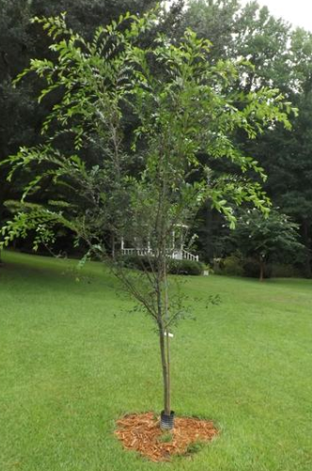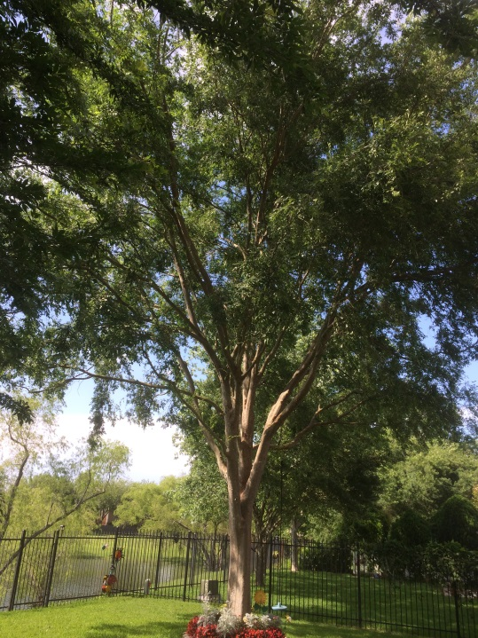
This did not happen overnight. This magnificent tree took years to grow to get as big as it is now. There was a time when it was small and weak but over time, using what God provided for it each day (lots of sunshine, Rain and nutrients from the ground) it has grown into a mature tree. As big as this tree is it is still not done growing.
This tree is a lot like Faith. Faith starts out small, just like a seed, that someone plants in you. As you walk with the Lord, talk with the Lord, learn to rely on His provision (sunshine, Rain and nutrients) that little seed of faith within you will grow over time and become unshakable.
Again, What is Faith:
Hebrews 11:1 Now faith is the assurance of things hoped for and the conviction of things not seen.
We hope for eternal life and we have the conviction that Christ is the way to get there and we grow in faith day by day.
At the same time I planted this first tree I planted a second tree on the other side of my yard. Both trees I planted were the same size, same type of tree, same soil, same sun light but the second tree never really took root. It was always leaning and swaying in the wind. I had to tie it up with stakes & support lines hoping it would eventually take hold. Then one day when a heavy wind came (Hurricane Ike) that tree finally just feel over.
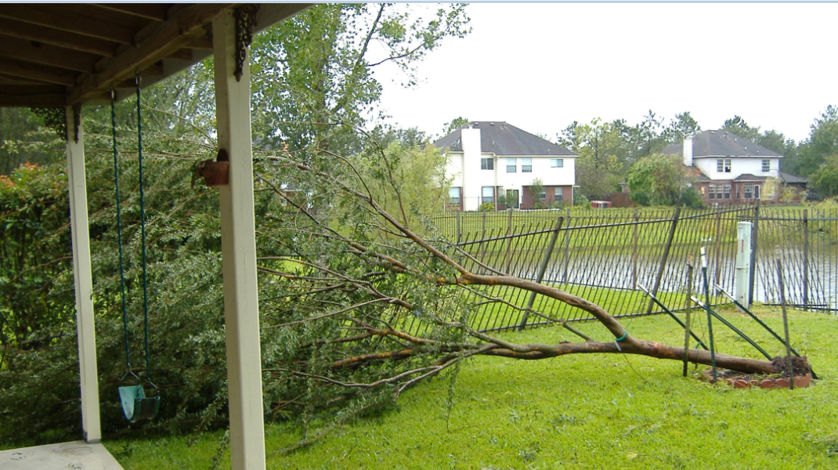
Notice the stakes in the picture are still standing. These support lines could be friends, Family, Job, Church or school that are holding you to Christ. Do you ever feel like your faith is tied up with support lines? What are they? What happens if they give way?
If we put all our trust in the support lines and not in the roots (Jesus Christ) then when the storms come those support lines let us down and our faith falls to the ground.
After the Storm I looked in the hole where the tree was planted and I noticed that it didn’t have very many roots
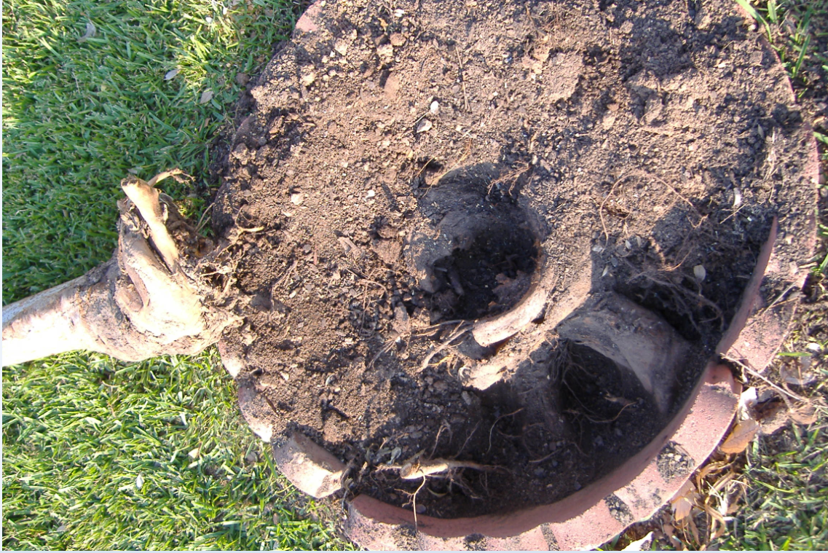
Some people when they come to except Christ they don’t fully trust God so they don’t give their whole life to him. These people may be Sunday Christians but the rest of the week they don’t pray or read their bibles. For them there is no real depth or roots to hold them in place so when hard times come their faith starts swaying in the wind.
The problem with having this type of faith is that when they are blown around by difficult situations and trials (Like a Hurricane) their faith isn’t strong enough to carry them through and they lose their faith and fall back into their old ways.
One test of your faith is how you react in a storm. Do you turn to Jesus for strength or do you try to handle it yourself, putting your trust in money, people or things, and end up in self-pity, anger or rage at the situation?
The tree that fell during the hurricane got chopped up and sent to the trash.
We see in Matthew 7: 19 Jesus said that “every tree that does not bear good fruit is cut down and thrown into the fire.”
As we grow in faith God should become bigger and our troubles and worries should become smaller.
This is how we know we are growing as Christians. This is not to say we will never have troubles or worries it is just how we respond to those troubles and worries. Do we trust God even in hard times or do we abandon our faith.
Proverbs 3:5 Trust in the LORD with all your heart; and lean not on your own understanding. In all your ways acknowledge him, and he will direct your paths.
Building strong faith takes time and commitment. It is something that cannot be rushed. If you try to rush into it you will become disappointed and start swaying in the wind. Take it one day at a time. Just like the tree needs the sun, rain and nutrients we need to study Gods word, Get involved in church, pray to God about your troubles and praise him when he delivers you. Take notes about things you learn along the way, write down your prayers and document when God answers them. For those prayers where you are still waiting on answers, keep praying and believing.
One day when you look back you will be amazed at how far you have come
There is Hope if you have lost your faith:
Job 14:7 “For there is hope for a tree, if it is cut down, that it will sprout again, and that its shoots will not cease.
Several months after the storm took down the weak tree. I went to dig out all the old roots, so I could plant a new tree, but I noticed just a small little sprout growing from the roots.
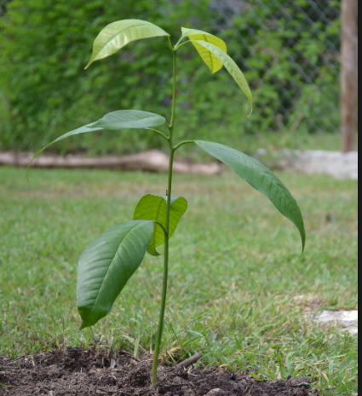
My family and neighbors all thought it was a weed and told me to pull it out and plant a new tree but I decided to let it grow and month by month, year by year it grew and grew into the most beautiful tree ever.
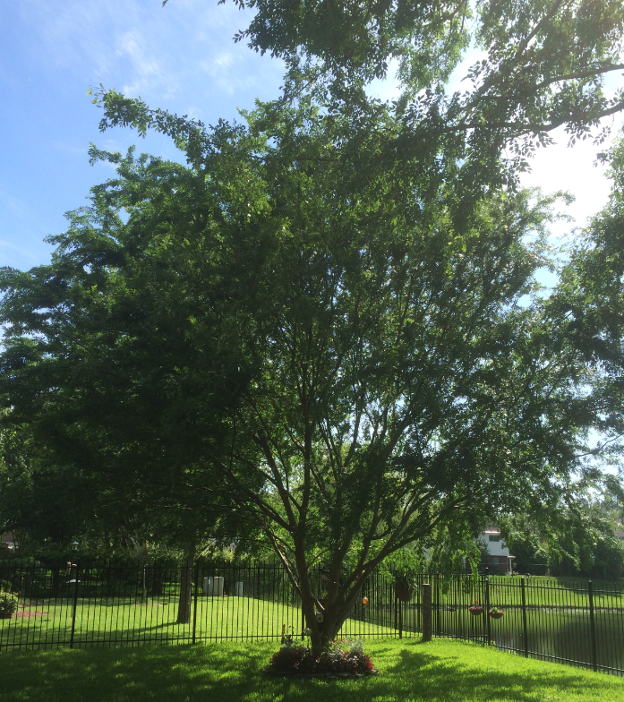
Everyone who has seen this tree remarks how beautiful it is and cannot believe it came up from the old tree. It is truly magnificent to look at.
When we are young in our faith it is easy to get blown around and even at times we might lose our faith all together and get blown over but that doesn’t mean we can’t get backup and try again. We definitely can’t do it by ourselves. We need Gods help.
Others may tell you “why try” or “just give up”. They will think your little faith is a weed and try to pull it out but if you stay focused on God you can become beautiful in Christ no matter how hard we have fallen. We just need to get back up and try again.
But having an unshakable faith doesn’t happen overnight and it does take work. We need to take time to get to know Jesus. Talk to him, Read about him and listen to others who have a relationship with him. And when your faith grows big and strong you can be a life wire that helps hold someone else’s faith in place when they are getting blown around.
James 1:12 Blessed is the man who remains steadfast under trial, for when he has stood the test he will receive the crown of life, which God has promised to those who love him.
If you think about it, Trees are amazing. God provides everything they need to grow. They live their whole life unable to move or provide anything for themselves. Yet God provides for their every need, right where they are.
This tree was used by God to strengthen my faith. This was actually the 3rd tree. The first tree never grew roots and blew down after several years. I dug it out and planted the second tree (Seen above) and when it got fairly big it started to sway in the wind also. Every time the wind blew I would run to watch and worry about that tree. During every storm I would pray that God would keep the tree up. I worried like this for several years. When Ike took it out I was even mad at God. It seemed like I would never be able to grow a tree in that spot.
And just when I was ready to give up, God gave me this little weed like sprout which renewed my hope. Since this little weed had the roots of a midsize tree to grow on, the little sprout had a great start and is now stronger than ever.
In the same way trials are there to make our faith strong we just need to get through them to see how awesome God will bless us on the other side. When we fall we still have the roots that have already been created to make us stronger the next time trials come around.
When God is in control the safest place to be is in the midst of the storm, just where he wants you. If you trust God with all your heart that storm can be like a hurricane blowing all around you but you will be standing in the eye, calm as ever. The Safest place for us to be is in the center of Gods will. The worst part of the storm is just outside the eye so if we sway just a little to the right or to the left and trust the world over God we can get caught up and tossed around. Put your trust in God and stand firm in your faith and God will get you through and Bless you big on the other side.
And If you find that you are not growing in your faith and service to God, maybe it is time to step back and evaluate your life and walk with God. Ask yourself what is working and what is not. Where do I need to focus more attention and what do I need to leave behind? And then go and Pray about it.
In Luke 13:18 Jesus said therefore, What is the kingdom of God like? And to what shall I compare it? It is like a grain of mustard seed that a man took and sowed in his garden, and it grew and became a tree, and the birds of the air made nests in its branches.
In your walk with Christ always remember trees Don’t grow up overnight. They take time. They weather the storms, The draughts, the diseases, those pesky woodpeckers. Your testimony will not be I meet Christ, I believed, I followed and all was good and easy. You will never hear that testimony. If you do, I would question it. If the enemy isn’t making things hard for you in your walk with Christ then you are probably right where he wants you. Your walk with Christ will require time on your knees weathering the storms!!!

Great Reading
- More than A Carpenter Josh McDowell
- Case for Christ Lee Strobel
- Sean McDowell Videos
  - https://www.youtube.com/watch?v=JNql36qIExA
  - https://www.youtube.com/watch?v=3oNdYQ2SO_I

